42.35: a) For maximum separation of 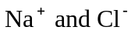 for stability:
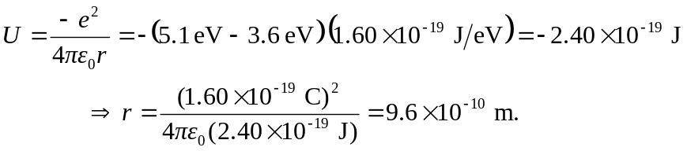
b) For 